
Delegate member profiles


September 1, 2014

VIBRANT GUJARAT SUMMIT 2015

Profile of Delegates
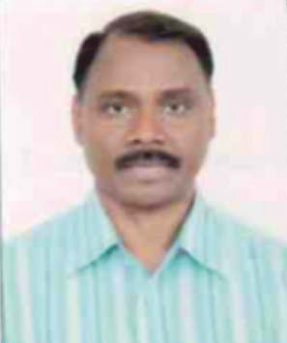
Full Name of Person | Mr. Girish Chandra Murmu, IAS
Company / Organization Name | Government of Gujarat
Designation | Principal Secretary to Hon'ble Chief Minister, Government of Gujarat
Address | Swarnim Sankul-1, Sachivalaya, Gandhinagar.
Contact Details | seclno@gujarat.gov.in

Delegate Profile
Mr. Girish Chandra Murmu, IAS, is Principal Secretary to the Hon'ble Chief Minister, Government of Gujarat. Mr. Murmu completed his graduation in Economics and Political Science and did his post-graduation in Political Science. He also holds a Post Graduate qualification in Business Management in Public Service from Birmingham University, U.K. Mr. Murmu has extensive experience in the banking sector and handling of NBFCs. He worked briefly in various banks like Andhra Bank, State Bank of India and Reserve Bank of India before joining the Administrative Services in 1985. As an IAS Officer he has vast experience in Policy planning and Policy making, Land Revenue Administration, Rural Sector Development, Regulatory and Law & Order administration. Mr. Murmu served as the Commissioner of Geology and Mining and as the Managing Director of Gujarat Mineral Development Corporation gaining acquaintance in Mines and Minerals sector. As Commissioner of Relief and Secretary Revenue he has efficiently handled various disasters like flood, cyclone and earthquakes. Mr. Murmu also serves as the director in various state owned PSU companies like Gujarat Alkalies & Chemicals Ltd., Gujarat Narmada Valley Fertilizers Co. Ltd., Gujarat Venture Fund Ltd., Gujarat Informatics Ltd. among others. He is also the Chairman of Gujarat Chemical Port Terminal Company Ltd. (Reliance Industries Limited Group)
Mr. Girish Chandra Murmu is the convener of this delegation.

Full Name of Person | Mr. Rupinder Singh Sodhi
Company / Organization Name | Gujarat Co-operative Milk Marketing Federation Ltd. (Amul) (www.amul.com)
Designation | Managing Director
Address | Gujarat Cooperative Milk Marketing Federation, PO Box 10, Amul Dairy Road, Anand 388 001, Gujarat, India
Contact Details | sodhi@amul.coop / rssamul@yahoo.com
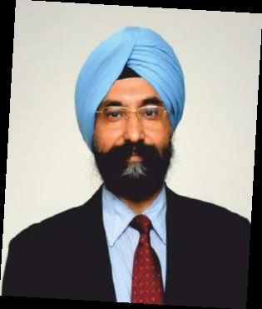
Company Profile
The Gujarat Cooperative Milk Marketing Federation Ltd, Anand (Amul) is the largest food products marketing organization of India and INR.11700 Crores (2.4 billion dollar) entity. It is the apex organization of the Dairy Cooperatives of Gujarat. Gujarat has been a pioneer in organizing dairy cooperatives and this success has not only been emulated in India but serves as a model for the rest of the World. Over the last six and a half decades, Dairy Cooperatives in Gujarat have created an economic network that links more than 3.2 million village milk producers with millions of consumers in India and abroad through a cooperative system that includes more than 16,117 Village Dairy Cooperative Societies (VDCS) at the village level, affiliated to 17 District Cooperative Milk Producers' Unions at the District level and GCMMF at the State level. These cooperatives collect on an average 111 million litres of milk per day from their producer members, more than 70% of whom are small, marginal farmers and landless laborers and include a sizeable population of tribal folk and people belonging to the scheduled castes.
Delegate Profile
Mr. R S Sodhi, Managing Director of Gujarat Cooperative Milk Marketing Federation Ltd., (GCMMF Ltd), Anand Gujarat, is the first-batch alumnus from Institute of Rural Management Anand (IRMA). Mr. Sodhi became the Managing Director of Amul India Ltd. in 2010, prior to which he served as Amul India’s Chief General Manager from June 2004 to June 2010. He has been with the Gujarat Cooperative Milk Marketing Federation Ltd (GCMMF) for over 30 years. He played a pivotal role in creating the GCMMF structure and has rich experience in Marketing and Sales function within the dairy industry. He has been responsible for enabling the organization to retain its dominance in the Indian Dairy Industry. Mr. Sodhi has been instrumental in taking brand 'Amul' to greater heights that it has scaled today. He has put in place key business processes which ensure smooth and seamlessly integrated functioning of a mega organization. Mr. Sodhi has also been a Non-Executive Nominee Director at Kaira Can Company Limited.
He has spoken at many International and national seminars, including events at Harvard Business School and Ismaili Economic Forum, Dubai. He has also been a guest faculty at ISB Hyderabad and IIM Ahmedabad.
Focus Sectors / Areas of Interest
Dairy &Food Processing

Full Name of Person | Mr. Zarir N. Langrana
Company / Organization Name | - Tata Chemicals Limited (www.tatachemicals.com)
Designation | Chief Operating Officer – Chemicals (India)
Address | Bombay House, 24 Homi Mody Street, Fort, Mumbai 400 001
Contact Details | zlangrana@tatachemicals.com
Company Profile
Part of the USD 83.5 bn Tata Group, Tata Chemicals Limited (TCL) is a global company with interests in businesses that focus on LIFE — Living, Industrial and Farm Essentials. Through its Living Essentials portfolio the company has positively impacted the lives of millions of Indians. Tata Chemicals is the pioneer and market leader in India's branded Iodized salt segment. With the introduction of an innovative, low-cost, nanotechnology based water purifier; it is providing affordable, safe drinking water to the masses. The company's Industry Essentials product range provides key ingredients to some of the world's largest manufacturers of glass, detergents and other industrial products. Tata Chemicals currently is the world's second largest producer of soda ash with manufacturing facilities in Asia, Europe, Africa and North America. Starting April 1st 2011, these key international subsidiaries have been rebranded as Tata Chemicals Europe Limited, Tata Chemicals Magadi Limited, Tata Chemicals South Africa Pty Limited, Tata Chemicals North America Inc., and Tata Chemicals (Soda Ash) partners. With its Farming Essentials portfolio the company has carved a niche in India as a crop nutrients provider.
Delegate Profile
Mr. Zarir N. Langrana is an Economics Graduate from the University of Madras and holds a Post Graduate qualification in Business Management from XLRI, Jamshedpur; he has attended advanced executive development programs at Harvard Business School and other institutions. He is currently the Chief Operating Officer of the Chemical SBU of Tata Chemicals and is responsible for its operations and growth in India. Till recently he headed the Global Marketing & Strategy function overseeing and directing all sales & marketing plans, developments, growth and new product activities and processes in these two areas for its Global Chemicals Business across the four continents where it operates. In addition, he has lead the post-merger integration programs within the Chemical SBU. Prior to this assignment he headed the Corporate Strategy & Business Development function and was a key player in the global inorganic growth of the SBU and in the M&A process. He has been with Tata Chemicals for over twenty five years having been inducted through the Tata Administrative Service. He has in the past worked within the Accounts, Finance and Project Management functions in Tata Chemicals. He has extensively traveled in India and abroad meeting a wide variety of customers and associates in the Industry. He is an active participant in various Industry and Trade Associations in the country and abroad.
Focus Sectors / Areas of Interest
Chemicals

Full Name of Person  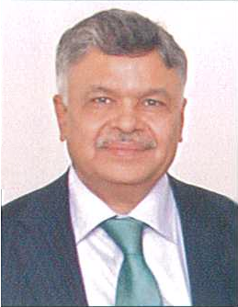 | Mr. Hemant Desai
Company / Organization Name | Reliance Industries Limited (www.ril.com)
Designation | President - Commercial & Corporate Affairs
Address | 1st Floor, Anand Mahal Buidling-1  Opp. Shreeji Arcade, Anand Mahal Road  Adajan, Surat -395 009 Gujarat India.
Contact Details | hemant.desai@ril.com
Company Profile
The Reliance Group, founded by Dhirubhai H. Ambani (1932-2002), is India's largest private sector enterprise, with businesses in the energy and materials value chain. Group's annual revenues are in excess of USD 66 billion. The flagship company, Reliance Industries Limited, is a Fortune Global 500 company and is the largest private sector company in India.
Backward vertical integration has been the cornerstone of the evolution and growth of Reliance. Starting with textiles in the late seventies, Reliance pursued a strategy of backward vertical integration - in polyester, fibre intermediates, plastics, petrochemicals, petroleum refining and oil and gas exploration and production - to be fully integrated along the materials and energy value chain.
The Group's activities span exploration and production of oil and gas, petroleum refining and marketing, petrochemicals (polyester, fibre intermediates, plastics and chemicals), textiles, retail, infotel and special economic zones. Reliance enjoys global leadership in its businesses, being the largest polyester yarn and fibre producer in the world and among the top five to ten producers in the world in major petrochemical products.
Delegate Profile
Mr. Hemant Desai is currently President (Commercial & Corporate Affairs) of the flagship company viz. Reliance Industries Ltd. and is part of the Core Corporate Leadership Team of the Reliance Group in Gujarat which has supported diverse corporate initiatives including Man-made Fibres Business, Hazira Petrochemicals Complex, Jamnagar Refinery, SEZ, Port Development, Gas Pipeline, Petroleum Retail, Telecom, Retail, 4th Generation Broadband Network Building, etc. Mr. Desai has been a part of Reliance’s Growth Story ever since 1982.Mr. Desai has played a key Role for the Group's initiatives in the Port & Port-led industrial development, Captive Power facilities, Environment Protection, etc.
Mr. Desai is also the Managing Director of Gujarat Chemical Port Terminal Company Ltd. (GCPTCL), a Joint Venture Liquid Chemical Port Terminal of Six PSUs of Govt. of Gujarat & RIL, strategically located within the Petroleum, Chemicals & Petrochemicals Special Investment Region (PCPSIR) Dahej which is poised to attract investments worth US $ 24 Bn. Currently, GCPTCL handles 2.2 MMTPA of Cryogenic Chemical & Petrochemical Cargoes like LPG, Propane, Naphtha, etc.
During his career span of 3 decades, Mr. Desai has spearheaded various Trade and Industrial Associations like the Hazira Area Industries Association (Hazira Area has investment worth US $ 25 Bn), Gujarat Captive Jetty Association. He also has the distinction of becoming the first Chairman of the Board of Management of Hazira Notified Area.
Focus Sectors / Areas of Interest
Chemicals & Petrochemicals
Full Name of the Person | Mr. Kishor Virani
Company / Organisation Name | KARP Impex Ltd. (www.karpgroup.com)
Designation | Chairman
Address | KARP House 8- A, Lal Darwaja 1  Surat – 395 003 Gujarat
Contact Details | kishorvirani@karpgroup.com
Company Profile
Established in the year 1983, KARP Impex is one of the leading manufacturer, importer and exporter of Cut & Polished Diamonds from India. The company has its manufacturing facility in Surat & Jasdan, (Gujarat), India accommodating more than 8,000 craftsmen, in its premier diamond cutting & polishing factories in the world with highly equipped state-of-the-art technology.
The company is a De Beers U.K Ltd. (formerly The Diamond Trading Company Ltd. (DTC)) Sight Holder. The company complies with Best Practice Principles (Assessed and Verified by SGS, Geneva), assures adherence to the Kimberly Process, Ensures Consumer confidence measures, Guarantees Conflict free diamonds, Executes Diamond Manufacturing Excellence (cut by world standard craftsmen), Exceptional standards of Community Service, Compliance to Pipeline Integrity (Assessed and Verified by SGS, Geneva).

As an international player the company is having offices in Hong Kong, Geneva, China, Belgium, Taiwan, Thailand and U.A.E. and the clientele base of the company is spread across Japan, Singapore, Hong Kong, Thailand, Israel, Europe, U.A.E., USA, Australia etc. The company believes in total customer service through quality management and timely delivery and this was recently re-emphasized by the ISO 9001:2008 accreditation secured by the company through SGS India Ltd. and the company has been also granted the status of “TRADING HOUSE” under the Export Import policy of the Government of India.
Delegate Profile
Mr. Kishor B. Virani is Chairman of KARP Impex Ltd. a leading manufacturer, importer and exporter of cut & polished diamonds from India. By qualification Mr. Virani is BE Mechanical Engineer from Birla Vishwakarma Mahavidhyalay, Vallabh Vidhya Nagar. As a visionary, he believes in blending art and technology to fetch highest level of accuracy. With extensive knowledge base in technology and varied expertise & experience of more than 34 years in the field of diamond cutting and manufacturing he has helped the company reach its highest level.
After having achieved success in the diamond industry he has also ventured into the Investment casting and is having more than 20 year of experience in this field under the name of Hi Tech Investment Casting Ltd., Bhavnagar, Gujarat, India. He has diversified into the CNC machine building industry under the name of Jyoti CNC Pvt Ltd., Rajkot, Gujarat, India.
With interest in real-estate property and infrastructure development he has ventured into property business and is having more than 20 year of experience in this field. Mr. Virani is currently appointed as Honorary Counsel General of Kingdom of Lesotho.
Focus Sectors / Areas of Interest
Diamonds (Gems & Jewellery)
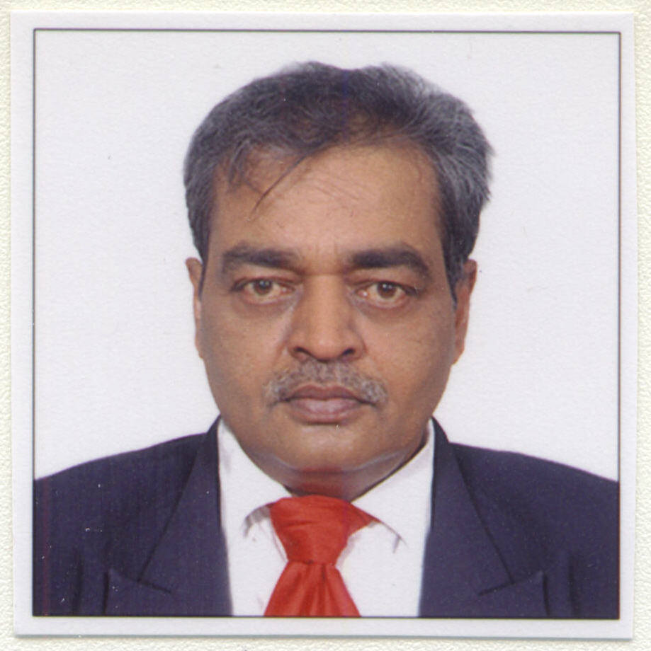

Full Name of Person | Mr Nitin Shukla
Company / Organization Name | Hazira LNG Private Limited (www.haziralngandport.com)
Designation | Managing Director & CEO
Address | 101-103, Abhijeet-II, Mithakali Circle,  Ahmedabad – 380006
Contact Details | nitin.shukla@shell.com
Company Profile
The Hazira LNG Terminal and Port is partnered by Shell Gas B.V and Total Gaz Electricité Holdings France, representing two of the largest private LNG suppliers in the world. The Hazira Terminal includes a liquefied natural gas (LNG) storage and re-gasification terminal within a fully functional port. The INR 3,000 crore Hazira LNG Terminal and Port facilities, in Surat district of Gujarat, is regarded as a key Foreign Direct investment (FDI) project and represents one of the largest international investments in India in the energy sector.
The Hazira (Surat) Port is designed as a deep-water, all-weather and direct-berthing port. It is situated in the State of Gujarat on the West Coast of India, about 25km from Surat city and about 120 nautical miles north of Mumbai. The port is built with a protected harbour design, with additional waterfront for development of non-LNG cargo handling terminals. Hazira (Surat) Port has an approach channel of about 1000m, turning radius of 600m and dredged draft of 12.5m with a capacity to accommodate larger vessels using tidal variance.
The Hazira (Surat) Port is planned as a ‘Gateway Port’ to serve the hinterlands of North, West & Central India where the container traffic is expected to grow exponentially. The Hazira (Surat) Port also falls close to the planned Delhi Mumbai Industrial Corridor (DMIC) and the high-speed dual carriageway constructed under the Golden Quadrilateral Project.
Delegate Profile
Mr. Nitin Shukla is the Managing Director and Chief Executive Officer of Hazira LNG and Port Companies. Hazira LNG and Port Companies jointly consist of Hazira LNG Private Limited, Hazira Port Private Limited and Hazira Gas Private Limited. Each of the Hazira LNG, Port and Gas Companies is a joint venture between Shell Gas B.V (Royal Dutch Shell Group) and Total Gaz Electricité Holdings France. All these are Shell operated companies.
Mr. Shukla holds a degree in Mechanical Engineering and Post Graduate Certificate in Industrial Purchasing & Materials Management. Prior to joining Shell, Mr. Shukla was the Managing Director of Gujarat PowerGen Energy Corporation Limited (GPEC); Executive Director, Gujarat Torrent Energy Corporation Ltd. and General Manager (Projects) at Nirma Limited. He has been involved in a number of large and complex projects while working for India’s largest engineering consultancy firm, Engineers India Limited.
Mr. Shukla is associated with Confederation of Indian Industry, Ahmedabad Management Association and various other social, educational and literary activities/ trusts, e.g., Gujarat Vishvakosh Trust and Darshak Itihas Nidhi. He is Fellow of The Institution of Engineers (India) as well as Fellow of The Chartered Institute of Logistics & Transport, India.
Focus Sectors / Areas of Interest: Oil & Gas
Full Name of Person  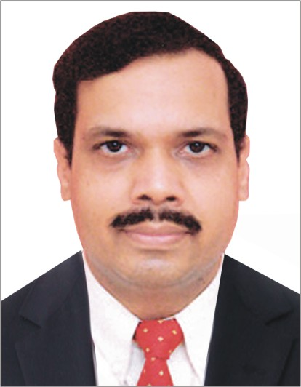 | Mr. Paritosh Gupta
Company / Organization Name | IIDC Limited  (Formerly IL&FS Infrastructure Development Corporation Ltd) (www.iidcindia.co.in)
Designation | Chief Executive Officer
Address | 2nd Floor, Niryat Bhawan,  Rao Tula Ram Marg, Opposite Army Hospital, Research & Referral  New Delhi 110057
Contact Details | paritosh.gupta@ilfsindia.com

Company Profile
Infrastructure Leasing & Financial Services Limited (IL&FS) is one of India's leading infrastructure development and finance companies.IL&FS was promoted by the Central Bank of India (CBI), Housing Development Finance Corporation Limited (HDFC) and Unit Trust of India (UTI). Over the years, IL&FS has broad-based its shareholding and inducted Institutional shareholders including State Bank of India, Life Insurance Corporation of India, ORIX Corporation – Japan and Abu Dhabi Investment Authority.

IL&FS has a distinct mandate - catalyzing development of infrastructure in the country. The organization has focused on commercialization and development of infrastructure projects and creation of value added financial services. From concept to execution, IL&FS houses the expertise to provide complete array of services necessary for successful project completion: visioning, documentation, development, finance, management, technology and execution.

IL&FS is widely recognized as the pioneer of Public Private Partnership in India. Today IL&FS has evolved into a prominent institution that harnesses the power of Public Private Partnership. IL&FS has sponsored various infrastructure projects, developed in conjunction with Governments, financing agencies, private sector partners and communities. This unique Public Private Partnership helps to leverage limited public funds, reduce life cycle cost, develop and execute more projects on a sustainable basis. IL&FS offers a full range of financial, project development and management services, including investment banking, project financing, project development, management and implementation, asset management, merchant banking, corporate advisory services and back office services.
Delegate Profile
Mr. Paritosh Gupta, is the Chief Executive of Infrastructure Leasing & Financial Services Limited (IL&FS) & Chief Executive Officer of IIDC Limited (a 100% subsidiary of IL&FS). Mr. Gupta has done his M.A. (Economics) from Delhi School of Economics and MBA from Indian Institute of Management, Lucknow with specialization in Marketing and Finance. He is also the recipient of the British Nehru Fellowship Award and Monbusho Fellowship Award. His key areas of expertise include Infrastructure Project Development, Structured Infrastructure Financing, Private Equity, Venture Capital, Early Stage Investing and Innovation Management.
Prior to joining IL&FS, he was associated with the Uptron Group and SIDBI.
Focus Sectors / Areas of Interest
Infrastructure; Finance

Full Name of Person  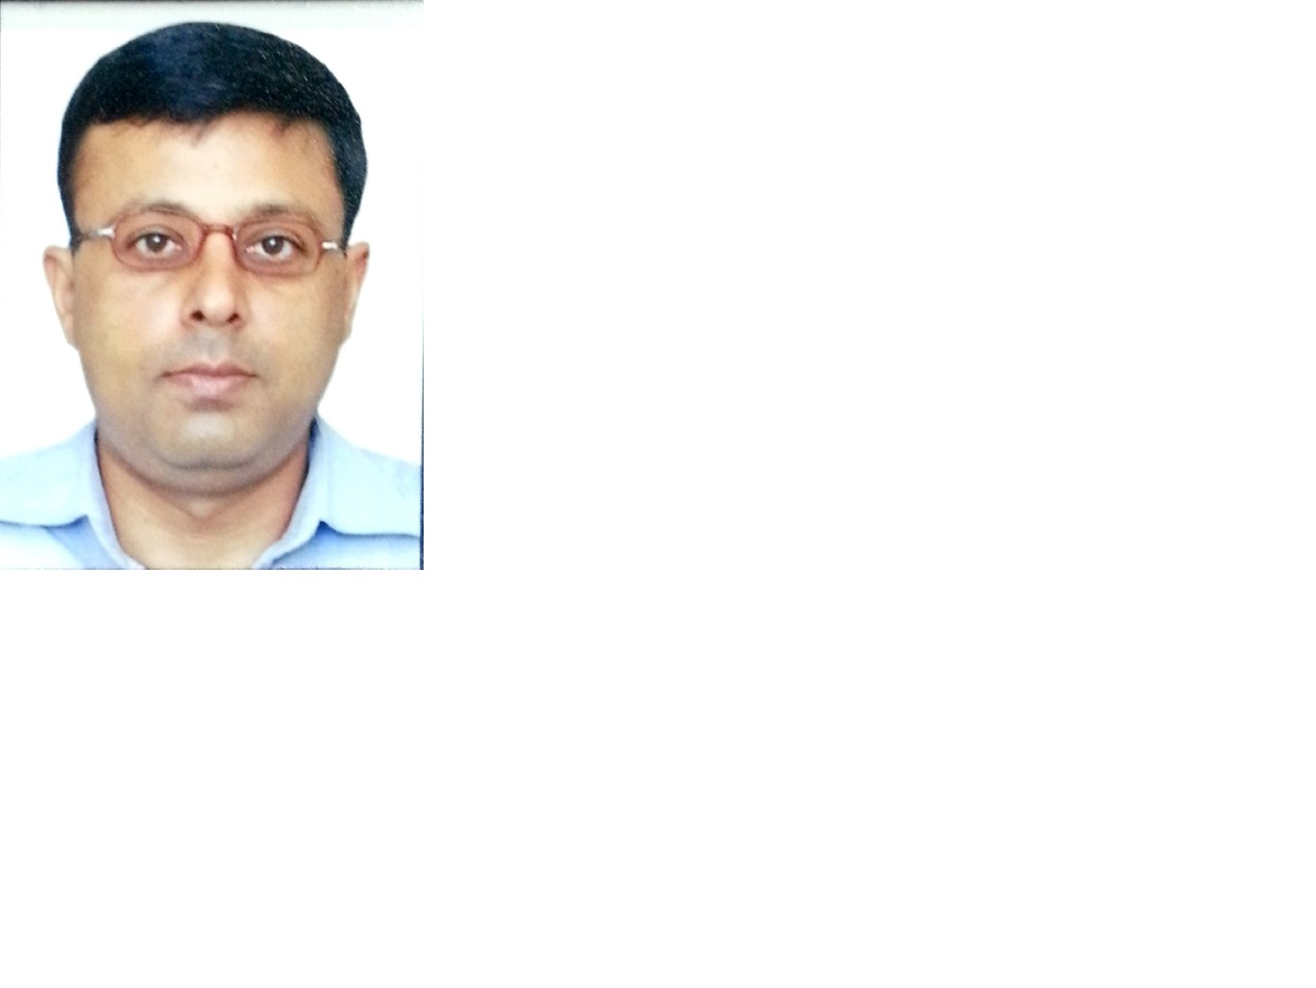 | Mr. Devendra Agrawal
Company / Organization Name | Gujarat State Petroleum Corporation Limited (www.haziralngandport.com)
Designation | DGM - Commercial
Address | GSPL Bhavan, Plot No E-18, GIDC Electronic Estate, Sector – 26, Gandhinagar – 382024
Contact Details | devendra@gspc.in
Company Profile
Gujarat State Petronet Limited (GSPL), a Gujarat State Petroleum Corporation Group company is a pioneer in developing energy transportation infrastructure and connecting natural gas supply sources including LNG terminals to growing markets. GSPL is continuously expanding its pipeline network currently in Gujarat to reach the demand centres by laying gas pipeline network. The company has developed requisite expertise and confidence with proven project management competencies.
GSPL is first Pipeline Company in India operating on open access basis and is a pure transmission network.The transmission network of the company envisages development of systematic and seamless pipeline network across Gujarat connecting various suppliers and users. The suppliers of natural gas include traders, producers and LNG terminals. The users comprise industries such as power, fertilizer, steel, chemical plants and local distribution companies.
GSPL along with its consortium partners, Indian Oil Corporation Limited (IOCL), Bharat Petroleum Corporation Limited (BPCL) and Hindustan Petroleum Corporation Limited (HPCL) is implementing three cross country pipeline projects awarded by Petroleum and Natural Regulatory Board (PNGRB): Mallavaram (AP) to Bhilwara (Rajasthan), Mehsana (Gujarat) to Bhatinda (Punjab) and Bhatinda (Punjab) to Shrinagar (J&K). The projects are being implemented under two SPVs.
Delegate Profile
Mr. Devendra Agarwal holds degree in Electrical Engineering and has also done Master of Business Administration in Finance. He has over 18 years’ experience in gas marketing, transmission, sales contracts and gas pricing. Mr. Agarwal has been associated with GSPC Group since March 2001 and is currently responsible for Business Development, LNG Sourcing & Gas Trading, Gas Transmission business, Contract Negotiation and Contract Management for gas business.
Focus Sectors / Areas of Interest: Gas

Full Name of Person  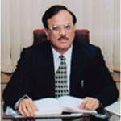 | Mr. Jaimin Vasa
Company / Organization Name | Vasa Pharmachem Pvt. Ltd (www.vasapharmachem.com)
Designation | Managing Director
Address | D-1 & D-2, 2nd Floor, "Nikumbh", Nr. Reliance House, C.G.Road, Ahmedabad 380 006. Gujarat, India.
Contact Details | jrvasa@vasapharmachem.com

Company Profile
Vasa Pharmachem Pvt. Ltd. (VPPL) is a privately held company, established in the year 1988. The company manufactures markets and distributes pharmaceuticals raw materials and specialty chemicals with its state-of-the-art manufacturing facility located in the heart of Ahmedabad. VPPL is committed to manufacture and market pharmaceuticals recipients to India and International markets. VPPL is committed to constantly serving customers worldwide by delivering medicines that truly improve the quality of human life. Vasa Foods and Beverages Pvt. Ltd., group company of VPPL, is manufacturing and marketing food and wellness products.
The Vasa Group has customized it's product to the need of its customers by adopting different production technologies and employing high technical expertise. A well-equipped Laboratory to check the quality of our raw-materials and our finished products, along with a team of experienced and diligent staff, the company consistently delivers quality and timely service.
Delegate Profile
Mr. Jaimin R. Vasa is a Chemical Engineer from Dharamsinh Desai Institute of Technology (DDIT). He has more than 30 years’ experience in manufacturing & marketing of Fine Chemical & Industrial Chemical and marketing activities of Pharmaceutical Raw Materials, Intermediates. He is the Managing Director of M/s. Vasa Pharmachem Pvt. Ltd., Director of Vaishali Agencies Pvt. Ltd, Vasa Laboratory & Chemical Pvt. Ltd. & Vasa Wellness Pvt. Limited.
Mr. Vasa is associated with several associations and is also a member in many committees:
- Chairman of the MSME Committee of Gujarat Chamber of Commerce and Industry
- President of Gujarat Chemical Association since 1999
- Vice Chairman of Gujarat Innovation Society (GIS)
- Member of State Level Inter-Institutional Committee (SLIIC) of Reserve Bank of India
- President of Behrampura Industrial Association
- President of Gujarat Pharmaceutical Association
Focus Sectors / Areas of Interest
Pharmaceuticals & Realty Chemicals

Full Name of Person  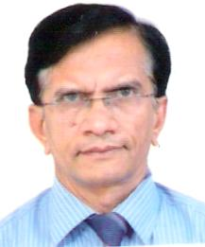 | Dr.P.A.Joshi
Company / Organization Name | Bharuch Enviro Infrastructure Ltd. (BEIL) (www.tatvaglobal.com)
Designation | Director
Address | 117–118, G.I.D.C., Ankleshwar, Gujarat–393002
Contact Details | pajoshi24@gmail.com

Company Profile
Bharuch Enviro Infrastructure Ltd. (BEIL) is a Company that specializes in the management of solid and hazardous waste. It operates a centralized landfill site along with a common incineration system built specifically for the safe and secure disposal of hazardous waste coming in from member industries in the region. Located in Ankleshwar, the landfill site at BEIL is the first facility in India to be certified under ISO 140001, and is amongst the few elite facilities in the world to have been awarded this certification.

In addition to the management of hazardous waste, BEIL is also engaged in the management of organic (kitchen) waste collected from nearby households. This waste is processed in a Biomethanation plant using state-of-the-art technology to generate valuable fuel.

Delegate Profile
Dr. P.A.Joshi is independent Director on Board of Bharuch Enviro Infrastructure Ltd and Enviro Technology Ltd. He is also a Professor of Chemical Engineering and former Dean, Faculty of Technology, Dharmsinh Desai University, Nadiad (GUJARAT). Presently he is Chairman of Anchor Institute-Chemical & Petrochemicals (promoted by Industries and Mines Department, Government of Gujarat) and Acting Director, Shah Schulman Center for Surface Science & Nanotechnology, DDU. He is also appointed as the Ministry of Commerce & Industries, Government of India’s nominee Director of Narmada Clean Tech Ltd.

Dr. Joshi did his bachelor’s degree in chemical engineering from Gujarat University, M.Chem.Engg. from UDCT, Mumbai, Ph.D. from IIT Bombay, FDPM from IIM Ahmedabad and a course on Cleaner Production from University of Adelaide, Australia. He had worked as PG Coordinator in Institute of Technology, Nirma University of Science and Technology, Ahmedabad, Professor and Head, Chemical Engineering Department, Government Engineering College, Gandhinagar and Research Engineer with M/s. Standard Alkali, Thane, Mafatlal Group Company. He was conferred “Excellence in Education” award by Gujarat Chemical Association. He has 36 years of UG and PG teaching, research, administrative and consultancy experience and has interest in energy and environment, fluidization engineering and nanotechnology.

Focus Sectors / Areas of Interest
Cleantech, Waste Water Treatment, Nanotechnology, Chemicals & Education

Full Name of Person   | Mr.Shital Patwa
Company / Organization Name | Shah-Schulman Center for Surface Science and Nanotechnology, Dharmsinh Desai University (sscssn.ddu.ac.in)
Designation | Director - Administration & Industrial Liaison
Address | Shah-Schulman Center for Surface Science and Nanotechnology, DDU, College Road, Nadiad387001, Gujarat
Contact Details | shitalpatwa@yahoo.com

Company Profile
Shah-Schulman Center for Surface Science and Nanotechnology was established in April 2008 under a unique model: a partnership between University, Government and the Industry. The Shah-Schulman Center for Surface Science and Nanotechnology (SSCSSN) is established in the Faculty of Technology, Dharmsinh Desai University (DDU), Nadiad, Gujarat, India with initial funding from Industries & Mines Department, Government of Gujarat. Dharmsinh Desai University is one of the most reputed technology institutes in industrially affluent state of Gujarat in Western India. It has trained scientists and engineers to provide a leadership in academia and industry since 1968.
The SSCSSN is an R & D Center that accommodates about 18 sophisticated instruments to carry out research and analysis in Surface Science and Nanotechnology. There are 3 core faculties and 5 associated faculties and 8 research scholars involved in the functioning of R&D activities of the Center. SSCSSN is established on a truly joint partnership of academia, industry and government.

With inputs from industrial advisory board, comprising 25 industrial partners of diverse industrial background in short span of 5 years since its establishment, Center has earned 4 Government sponsored research projects and 4 Industry funded projects. SSCSSN has 6 registered PhD students and in past 4 years published more than 20 research publications in international peer reviewed journals, having average impact factor more than 2.50.SSCSSN has entered in to tri-partite agreement with University of Florida and Columbia University under the IUCRC program of National Science Foundation, USA. Dept. of Science & Technology-India will support this program in India. Under this program 25 companies have joined SSCSSN as Industry Advisory Board Members for Industry oriented research activities. SSCSSN-DDU is one of the first such partners from Gujarat to enter into this NSF sponsored International program.
Delegate Profile
Mr. Shital Patwa is Director, Administration & Industrial Liaison, Shah-Schulman Center for Surface Science and Nanotechnology, DDU, Nadiad, GUJARAT, INDIA. Mr. Patwa has a vast experience in industries namely Chemicals / Engineering / Maintenance of Roads, Bridges and Buildings. He is one of the pioneers and visionary for setting up of this Research Center and R & D facilities at DDU. He is also the Managing Director at Heat Chem Engineering Pvt. Ltd. (manufacturers for heat ventilation systems and process equipment), Chairman and founder of DOS Advanced Agro Biotech Ltd. Agro Biotech products and Life sciences and CEO of Rimpro India( manufactures and exporters for surfactants, oil field chemicals, cosmetic wax and specialty chemicals).He has done his graduation in B.A. Psychology from St. Xavier’s College Ahmedabad India.
Focus Sectors / Areas of Interest
Nanotechnology, Chemicals & Education
Full Name of Person | Dr. Ashok Shah
Company / Organization Name | Prasad Biotech (organicprasad.com)
Designation | Director
Address | 725, G.I.D.C, New. Gundlav, Valsad - 396 035. Gujarat -INDIA
Contact Details | dracshah13@yahoo.com

Company Profile
Prasad Biotech are supplier and manufacturers’ of natural/ organic farming products, agro forestry, medicinal plantation, biotechnology, bio-compost, bio-cultures, animal feed etc. Products of Prasad Biotech help in improving the agricultural outputs and quality with environmental protection and improvement. The company manufactures organic products as per the specification for bulk and industrial buyers. These products help in preventing pests/diseases effectively and also reduces usage of other insecticides/pesticides to a great extent. The products help improve growth and protect plants from various adverse conditions, thereby improving the crop survival rates. Prasad Biotech products are uniquely formulated with years of organic experience where natural extracts are blended with specially processed anti-feedent and growth promoters. The company is also in to trade of various Microbial Fermentations, Industrial Biotechnology & Agricultural Biotechnology from Laboratory scale to Industrial levels viz. vitamins, enzymes, antibiotics, steroids, distilleries, bicultural, fine chemicals etc. Agrishaktee and Kaizen are two of their most prominent products.

Delegate Profile
Dr. Ashok Shah is M.Sc., Ph.D. (Microbiology) and has a long industrial experience serving in several senior positions. Dr. Shah has developed various products with the use of seaweed plants, bacterial extracts and cow urine. He has visited various countries for technical expertise and studies. Dr. Shah provides practical guidance in the fields of Organic Agriculture, Biotechnology, Traditional Medicinal / Aromatic preparation, Agroforestry etc. He also provides consultancy services for organic farming of crops like wheat, rice, maize, cotton, sugarcane, groundnut, pulses and in horticulture most of the fruits, vegetables, flowers and on cultivation of medicinal and aromatic plants. He served as a Non-Executive Independent Director of Gujarat Narmada Valley Fertilizers & Chemicals Limited from January 4, 2006 to June 2014. He is a member of Advisory Board Microbiology and FR South Gujarat University, Surat. He also serves as a Director of Gujarat Venture Finance Company Limited and is a Member of its Shareholders’/Investors’ Grievance Committee. He has won many outstanding performance awards in the past in the fields of Organic Farming, Medicinal and Aromatic Plants, Value Addition and Spiritual Plantation.

Focus Sectors / Areas of Interest
Agriculture, Biotechnology

Full Name of Person  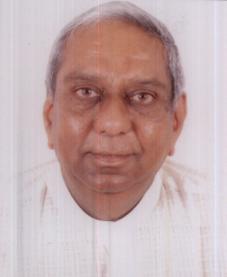 | Mr. Kalyan Shah
Company / Organization Name | Jayatma Group (www.jayatma.com )
Designation | Chairman
Address | 1, Laxminagar Society, Besides Naranpura Post Office, Naranpura, Ahmedabad – 380 013, Gujarat, India
Contact Details

Company Profile
Jayatma group has interests in Textile, Information Technology and Logistics. It has a PAN India presence and caters to international markets across Asia, Europe & Africa encompassing a team of more than 2000 + people with annual revenues of USD 35 million.

Jayatma Informatics Private Limited, an IT and ITeS Company is known for its flagship business of end-to-end Content Management Services. It is a force to reckon with for its expertise as a process enabler across all major verticals. JIPL now has built on its core strength and added business streams of Software Application Development. Systems Integration, IT infrastructure Management etc. We provide Best Practice Outsourcing Services for Software Solutions, Document Scanning, Data Processing, Multimedia Creations, BPO / KPO and Hardware/Networking enabling other organization to successfully unlock the true value of the information contained in its files, resulting in increased productivity, performance and profits. We are recognized experts in providing Software Solutions, Multimedia Creations and Document Scanning services. We also provide facilities for warehousing of records and record management. We offer tailor made solutions to different segments of economy.

Santaram Spinners Limited (A Public Listed Company) and Giriraj Cotton Limited, are the textile arms of the group. The group has one of the most modern cotton ginning unit, strategically located in the cotton growing bowl with a capacity to produce 500 metric tonnes per day. It is one of the few manufactures of contamination controlled cotton bales. Quality of Cotton Produce of company commands significance Value among International Buyers of Cotton.

Delegate Profile
Mr. Kalyan J. Shah, is the Chairman of Jayatma Group, Head quartered In Ahmedabad, (India). An industry veteran, Mr. Kalyan Shah, has rich experience of more than 40 years. He has served as the President of Gujarat Chamber of Commerce & Industry and has also been the Hon. Secretary as well as Vice President. He has been a Board Member of Gujarat Electricity Board. Mr. Shah is also a philanthropist and contributes extensively to the wellbeing of the society.

Focus Sectors / Areas of Interest
Textiles, Information Technology & Logistics

Full Name of Person  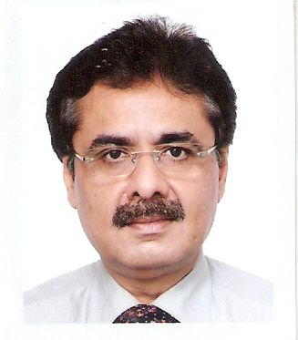 | Mr. Saurin Shah
Company / Organization Name | Adani Group (www.adani.com )
Designation | Joint President
Address | Adani Enterprises Ltd, Adani House, Nr Mithakhali Circle, Navrangpura, Ahmedabad 380 009, Gujarat
Contact Details | saurin.shah@adani.in

Company Profile
Adani Group is a business behemoth based in India having a global footprint with interests in Infrastructure, Power, Global Trading, Logistics, Energy, Port & SEZ, Mining, Oil & Gas, Agri Business, FMCG products, Real Estate Development, Bunkering, et al. It is a name well established among the distinguished corporate entities of India, with a young and highly motivated taskforce of professionals who are a prized asset of the organization.
Founded in 1988 with a capital of INR 500,000, Adani Enterprises Ltd. (formerly known as Adani Exports Ltd.) is today the flagship company of the Adani conglomerate which posted INR 260 billion revenue in the previous financial year. The Adani Group has many distinctions to its merit; Operator of the largest private port in India, Developer of the largest multiproduct SEZ in India, Owns the largest edible oil refining capacity in India, One of the largest trading houses in India, Largest Integrated Coal Management Firm in India, Promoter of India’s first supercritical technology based power plant, Operator of the world’s largest automated import Coal Terminal having 60 Million Tonne capacity, etc.
The Adani Group is engaged in a continuous endeavour to maximize the realization of potential in its employees and market opportunities by synergizing the multiple ventures of the Group; thus creating an optimum business model that benefits both, stakeholders and society.
Delegate Profile
Mr. Saurin Shah was born in a family of businessmen. After his graduation, he was inducted in the family business of plastics, textiles and textiles machinery and used this platform to sharpen his expertise. As a blessing in disguise, when the textiles industry in Gujarat, known as the Manchester of India, started to limp, he felt the need to explore new avenues of operation to brush up his business acumen. He joined Adani Exports in 1993, the then leading exporters of Agro Products and Textiles. It was a decisive turning point of the professional life of Mr. Shah.
He has helped the Group to make rapid strides in the core sectors like coal, power, ports, shipping, mines, SEZ etc. Mr. Shah is well versed with the nitty-gritty of international business and considered as an authority in conceptualizing new projects of the group and its successful conception. Mr. Shah, as the Head of Group Corporate Affairs, plays a pivotal role in formulating the policies of the Group and he ensures effective liaisoning with bureaucracy and political hierarchies for its expeditious implementation.
Mr. Shah has carved out a niche position in the corporate world by his exemplary performance and he is an inspirational force to colleagues.
Focus Sectors / Areas of Interest
Power, Ports, Shipping, Mines and Infrastructure

Full Name of Person | Mr. Mahendra N. Patel
Company / Organization Name | Mamata Group (http://mamata.com)
Designation | Chairman
Address | Survey No. 423/P, Sarkhej Bavla Highway, Moraiya, Tal:Sanand, Dist:Ahmedabad-382213, Gujarat, India
Contact Details | mahendra@mamata.com


Company Profile
Mamata Machinery Pvt. Ltd. (100 % Patel family)- own technology development and product design
Manufacturing and worldwide direct marketing of :
  - Converting machinery
    - Bag making machines (< 1500 wide x 250/min.)
    - Pouch making machines (< 600 wide)
  - Form, fill & seal (FFS) machines
    - Vertical sachet FFS (< 400 sachet/min.)
    - Vertical pillow FFS (< 70 bags/min.)
    - Horizontal Standi pouch FFS (< 120 bags/min.)
Mamata USA Inc. (100% subsidiary of MMPL)
  - Montgomery, IL, USA. (Near Chicago)
  - Pouch and Wicketer machines for North American markets
  - Customization of Mamata machines
Mamata Enterprises Inc. (100% subsidiary of Mamata USA Inc.)
  - Bradenton, FL, USA. (Near Tampa)
  - Flexible packaging horizontal FFS machines
Two Joint Ventures with Klöckner Werke AG, Germany – continuing partnership since 1982 beginning as Klöckner Windsor India limited
Klöckner Desma Machinery Pvt. Ltd. (1994)
  - JV with Klöckner Desma GmbH of Germany
    - Exited in 2010 but continuing association as Managing Director
  - Rubber injection moulding machines (< 250 MT)
KHS Machinery Pvt. Ltd. (1997)
  - JV with KHS GmbH
    - Minority share but continuing as Executive Vice Chairman
  - Beverage bottling lines – (600+ bottles/min.)
  - Bottle washers, conveyors, proportional mixing systems
  - Filling machines for soft drinks, water, beer, wine
    - Glass or PET bottles & aluminum cans
Other Joint Ventures
- Ferromatik Milacron India Ltd. (1995)
- Mamata Extrusion Systems Pvt. Ltd. (1996)
- Mamata Energy Pvt. Ltd.
- Mamata Span Flexo Pack Pvt. Ltd

Delegate Profile
Mr. Mahendra Patel did his Post Graduatation in Industrial Engineering and Administration from the Cranfield University, UK. Her eturned to India in August 1974 after studies in England, UK and started his first venture, Patel Filters Limited, Ahmedabad, in 1977. He started Mamata Machinery Pvt. Ltd., Ahmedabad, in 1982. He established Mamata Group in 1995.
Mr.Patel has held several senior management and member postions across manyorganizatioans and associations. Currently, he is :
- Member of National Executive Committee, FICCI
- Chairman of National Advisory Board, Plastindia 2015
- Chairman of Plastics Machinery Manufacturers Association of India
- Permanent Managing Trustee of Vatva GIDC Industrial Association Charitable Trust
- Trustee Kadi Sarva Vidyalaya Kelavani Mandal, Kadi and Gandhinagar
- Trustee Ganpat Vidyalaya, Kherva
Focus Sectors / Areas of Interest
Plastics, Energy & Machinery Manufacturing

Full Name of Person   | Mr Philippe Tolllini
Company / Organization Name | Larsen & Toubro (www.larsentoubro.com )
Designation | Director-Business Director (Europe & CIS Countries)
Address | LARSEN & TOUBRO Limited  17 rue Galilée  75016 Paris, France
Contact Details | philippe.tollini@larsentoubro.com

Company Profile
Larsen & Toubro Limited (L&T) is a technology, engineering, construction and manufacturing company. It is one of the largest and most respected companies in India's private sector. More than seven decades of a strong, customer-focused approach and the continuous quest for world-class quality have enabled it to attain and sustain leadership in all its major lines of business.
L&T has an international presence, with a global spread of offices. A thrust on international business has seen overseas earnings grow significantly. It continues to grow its global footprint, with offices and manufacturing facilities in multiple countries. The company's businesses are supported by a wide marketing and distribution network, and have established a reputation for strong customer support.
L&T believes that progress must be achieved in harmony with the environment. A commitment to community welfare and environmental protection are an integral part of the corporate vision.In response to changing market dynamics, L&T has gone through a phased process of redefining its organization model to facilitate growth through greater levels of empowerment. The new structure is built around multiple businesses that serve the needs of different industries :
- Hydrocarbon
- Heavy Engineering
- L&T Construction
- Power
- Electrical & Automation
- Machinery & Industrial Products
- Information Technology
- Financial Services
- Shipbuilding
- Railway Projects
Delegate Profile
Mr. Philippe Tollini joined LARSEN & TOUBRO on January 1st, 2012 as Director - Business Development (Europe & CIS countries) - dedicated to the Nuclear, O&G, Defence and Shipbuilding industries.
After completing his Master’s Degree in Industrial Engineering in France in 1988, Mr. Tollini joined a reputed large engineering organization involved in EPC business dedicated to the steel industry, as mechanical engineer in their USA subsidiary before taking more important roles back in France in the sales of steel plants within the Asian region. He, later on, moved to the manufacturing business of nuclear main island equipment (forging and fabrication) inside the AREVA group, where he served in the capacity of Vice-President Sales and marketing.
Within AREVA, Mr.Tollini fined tuned his education by attending an Executive MBA training from the Harvard Business School in 2007.
Focus Sectors / Areas of Interest
Nuclear, Oil & Gas, Defence & Shipbuilding

Full Name of Person | Mr Vishal Sanghavi
Company / Organization Name | Tata Advanced Systems Ltd. (www.tataadvancedsystems.com )
Designation | Senior Program Manager - Tata Lockheed Martin JV
Address | TATA Advanced Systems Limited  Thapar House Eastern Wing, Third Floor, 124 Janpath, New Delhi-110001
Contact Details | vsanghavi@tata.com
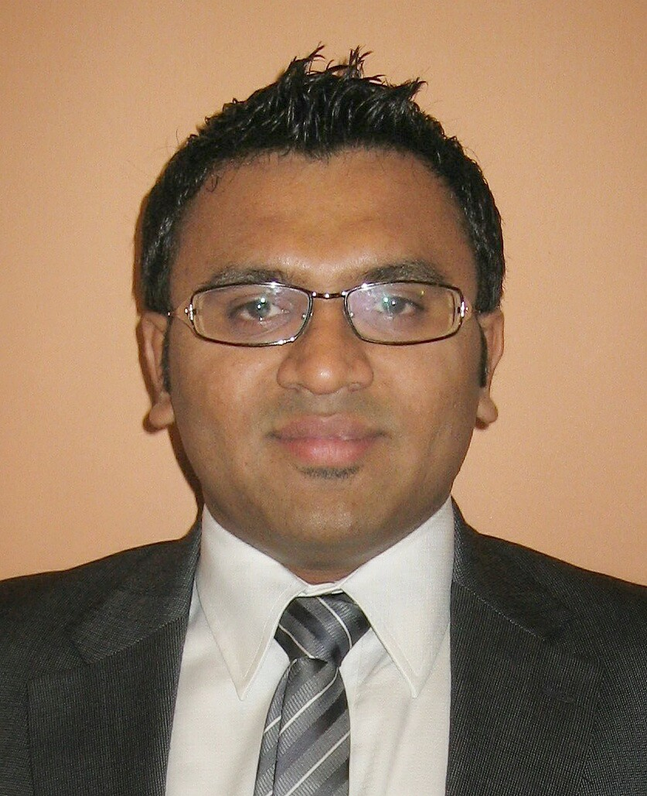
Company Profile
Tata Advanced Systems Limited (TASL), a wholly owned subsidiary of Tata Sons, is the strategic Aerospace and Defence arm of the TATA Group. TASL is both an operating & a holding company. TASL group is fast emerging as a key Defence and Aerospace player in India with established capabilities and demonstrated deliveries in the following areas:
- Missile Systems and sub-systems
- Radar Systems and sub-systems
- Command & Control Systems
- Aerospace & Aero-Structures
- Unmanned Aerial Systems
- Optronic Systems
- Homeland Security Solutions
TAS-AGT’s key focus areas include the following:
- Critical Infrastructure-Customized solutions for Installations such as Steel plants, Chemical plants
- Mass Transit - Railways, Metros, Airports, Road Transport Hubs, Express-ways, Highways
- Public Safety - Safe City, Safe Hotels, Tourist Places, Universities.
- Border, Marine and Coastal Security
- Integrated Building Management Solution (IBMS)
Delegate Profile
Mr. Vishal Sanghavi completed his B.E. in Electronics and Telecommunications from Mumbai University. Mr. Sanghavi has rich and diverse experience in Cross functional responsibility and accountability for Commercial and Contracts, Sourcing, Program Management, Operations Management, Government Approvals and has also led support functions including HR, IT and Admin. He was one of the founding members of the team that set up TATAs JV with Lockheed Martin for manufacturing of airframe parts of C130 aircraft and played a leading role in setting up the joint venture. He was involved in commercial negotiations for the multi-year multi-million dollar deal with Lockheed Martin governed by USA Federal Acquisition Regulations and developing a global supply chain and procured material worth multi-million dollars from more than 50 global vendors. He is also responsible for customer relationship with major aerospace OEMs like Airbus, Boeing, Bombardier, Pilatus, RUAG etc.
Focus Sectors / Areas of Interest
Defence & Aerospace

Full Name of Person | Mr Kapil Malhotra
Company / Organization Name | Abellon Clean Energy Limited (www.abelloncleanenergy.com )
Designation | Business Development Manager, European Region
Address | Sangeeta Complex,  Near Parimal Railway Crossing,  Ellisbridge, Ahmedabad - 380006,  India.
Contact Details | kapil.malhotra@abelloncleanenergy.com
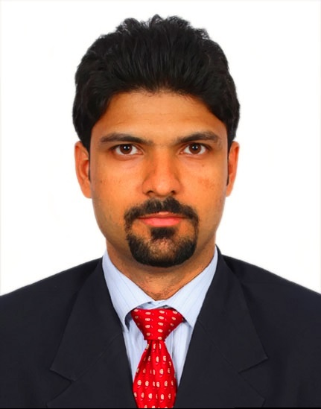
Company Profile
Abellon CleanEnergy is an integrated sustainable energy solutions provider with a vision to contribute to clean energy generation through bioenergy, including solid bio-fuel, liquid bio-fuels, bio-power, and other forms of clean energy generation.

The company's focus is on developing products and solutions that lower greenhouse gas emissions and productively harness the abundant energy of the sun, benchmarking processes such as photosynthesis, to convert it into useful forms of energy. Abellon has a portfolio of low-carbon energy technologies and a range of products and services, which together can meet the demands from the industrial, public and commercial sectors, as well as the community on a large scale.

Driven by a set of core values, Abellon is charting its course in the global renewable energy sector with a strong focus and presence in the bioenergy segment and other select domains.

Delegate Profile
Mr. Kapil Malhotra completed his Diploma in International Business, with a Masters in Energy from University of Petroleum and Energy Studies and B.E in Instrumentation and Control. He has broad experience in Energy Field. He has worked for Energy Infrastructure India Limited as Business Development Professional and MCX and NCDEX as an Energy Commodity Analyst. In 2008, he joined Abellon CleanEnergy Limited and is responsible for Business Development in the European region. He is an Energy Professional with broad Business Development and marketing expertise in Domestic and International Market. His specialties include, Business Development & Strategy, Distribution Channel Management and Marketing & Sales Planning.
Focus Sectors / Areas of Interest
Renewable Energy

Full Name of Person  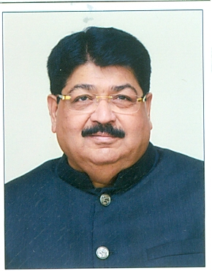 | Mr Parimal Nathwani
Company / Organization Name | Reliance Industries Limited ( www.ril.com) ; www.parimalnathwani.com )  Government of India
Designation | President (Corporate Affairs)  Member of Rajya Sabha
Address | “Vraj”, Near Suvidha Shopping Centre,  Paldi, Ahmedabad-380007 Gujarat India.
Contact Details | Parimal.nathwani@sansad.nic.in  pn.rajyasabha@gmail.com

Company Profile
The Reliance Group, founded by Dhirubhai H. Ambani (1932-2002), is India's largest private sector enterprise, with businesses in the energy and materials value chain. Group's annual revenues are in excess of USD 66 billion. The flagship company, Reliance Industries Limited, is a Fortune Global 500 company and is the largest private sector company in India.
Backward vertical integration has been the cornerstone of the evolution and growth of Reliance. Starting with textiles in the late seventies, Reliance pursued a strategy of backward vertical integration - in polyester, fibre intermediates, plastics, petrochemicals, petroleum refining and oil and gas exploration and production - to be fully integrated along the materials and energy value chain.
The Group's activities span exploration and production of oil and gas, petroleum refining and marketing, petrochemicals (polyester, fibre intermediates, plastics and chemicals), textiles, retail, infotel and special economic zones. Reliance enjoys global leadership in its businesses, being the largest polyester yarn and fibre producer in the world and among the top five to ten producers in the world in major petrochemical products.
Delegate Profile
Mr. Parimal Nathwani is the Group President(Corporate Affairs) of Reliance Industries Ltd. He has worked with Reliance Founder Chairman Shri Dhirubhai Ambani in the beginning of his career and at present finds a place in top echelon of RIL under chairmanship of Mr. Mukesh Ambani.
Mr. Parimal Nathwani is a Member of Rajya Sabha since 2008 and got elected for the 2nd term also in the year 2014. He has been Vice President of Dwarka Devasthan Samiti and a Member in Natdwara Temple Board since more than a decade. Mr. Nathwani has also been Vice President of Gujarat Cricket Association. As ardent lover of Wild Life, Mr. Nathwani has taken some meaningful initiatives to protect and conserve the world famous Asiatic Lions in Gir Forest, Gujarat. His book on Asiatic Lions of Gir, Gujarat is under print and publication. ’Jharkhand: Meri Karmabhoomi’ a coffee table book in Hindi is Mr. Nathwani’s report card of his term as a Rajya Sabha member. In nut-shell, Mr. Nathwani is a multi-faceted personality.
Focus Sectors / Areas of Interest
Chemicals and Petrochemicals

Full Name of Person | Mr Pankaj Tibak
Company / Organization Name | Confederation of Indian Industry(CII)
Designation | Deputy Director & Head Vadodara Zonal Office
Address

Contact Details | Pankaj.tibak@cii.in

Company Profile
The Confederation of Indian Industry (CII) works to create and sustain an environment conducive to the development of India, partnering industry, Government, and civil society, through advisory and consultative processes. CII is a non-government, not-for-profit, industry-led and industry-managed organization, playing a proactive role in India's development process. Founded in 1895, India's premier business association has over 7200 members, from the private as well as public sectors, including SMEs and MNCs, and an indirect membership of over 100,000 enterprises from around 242 national and regional sectoral industry bodies.
CII charts change by working closely with Government on policy issues, interfacing with thought leaders, and enhancing efficiency, competitiveness and business opportunities for industry through a range of specialized services and strategic global linkages. It also provides a platform for consensus-building and networking on key issues. Extending its agenda beyond business, CII assists industry to identify and execute corporate citizenship programmes. Partnerships with civil society organizations carry forward corporate initiatives for integrated and inclusive development across diverse domains including affirmative action, healthcare, education, livelihood, diversity management, skill development, empowerment of women, and water, to name a few.
The CII theme of ‘Accelerating Growth, Creating Employment’ for 2014-15 aims to strengthen a growth process that meets the aspirations of today’s India. During the year, CII will specially focus on economic growth, education, skill development, manufacturing, investments, ease of doing business, export competitiveness, legal and regulatory architecture, labor law reforms and entrepreneurship as growth enablers.
With 64 offices, including 9 Centres of Excellence, in India, and 7 overseas offices in Australia, China, Egypt, France, Singapore, UK, and USA, as well as institutional partnerships with 312 counterpart organizations in 106 countries, CII serves as a reference point for Indian industry and the international business community.
Delegate Profile
Pankaj Tibak working with the Confederation of Indian Industry since last eight & half years and currently heading Vadodara Zonal Office is a Science Graduate from Rajasthan University and a PGDBM from Bhavan’s College, Mumbai. He has over 27 years’ experience in Corporate Communications, Marketing & Sales, Events, Media and Brand Management. Currently handling Textile, Logistics & Agro & Food Processing Sectors, Liaisoning for International Delegations inward & outward, at State Level at CII. Over 10 years’ experience of handling International Business Delegations from various countries including Korea, UK, Switzerland, France, China, France, Singapore, Australia, Commonwealth Countries, Brazil, Tanzania, Nigeria, Italy etc. and organizing relevant meetings. Have been a part of Chief Minister’s Delegation to Africa in 2008 and has visited Kenya, Uganda, Tanzania, South Africa, Nigeria, Algeria, Morocco & Italy with business delegations.

Organizing Conferences, Seminars, Workshops & Exhibitions on different sectors including, Agro & Processed Foods, Logistics - Ports, Healthcare, Corporate Security, Textiles, Minerals & Mining, ICT etc.
Pankaj Tibak working with the Confederation of Indian Industry since last six & half years, a Science Graduate from Rajasthan University and a PGDBM from Bhavan's College, Mumbai. He has over 25 years’ experience in Corporate Communications, Marketing & Sales, Events, Media and Brand Management. Currently handling Textile, Logistics & Agro & Food Processing Sectors, Liaisoning for International Delegations inward & outward, at State Level at CII. Over 8 years’ of experience in handling International Business Delegations from various countries including Korea, UK, Switzerland, France, China, France, Singapore, Australia, Commonwealth Countries, Brazil, Tanzania, Nigeria, Italy etc. and organizing relevant meetings. Have been a part of Chief Minister's Delegation to Africa in 2008. Organizing Conferences, Seminars, Workshops & Exhibitions on different sectors including, Agro & Processed Foods, Logistics - Ports, Healthcare, Corporate Security, Textiles, Minerals & Mining, ICT etc.
CII is the National Partner for Vibrant Gujarat 2015 Summit

Full Name of Person | Mr Bharat M Mody
Company / Organization Name | iNDEXTb (A Government of Gujarat Undertaking)
Designation | Assistant General Manager (FDI & NRI) I/c. & Assistant Manager (International Business)
Address | Block No: 18, 2nd Floor, Udyog Bhavan, GH Rd, Sector 11, Gandhinagar, Gujarat 382010.
Contact Details | bmmody@indextb.com

Company Profile
Industrial Extension Bureau, popularly known as iNDEXTb is a Government of Gujarat Organization established in the year 1978 with the prime objective of accelerating the industrial development in the State. The Bureau acts as a single point contact for entrepreneurs for establishing their industrial ventures. In order to cater varied needs of entrepreneurs, iNDEXTb has established separate cells like International Business Division, Investment Promotion Division, Project & Technology Division, IT Division etc. which are headed by senior officers. The Bureau acts as catalyst of Industries Department of the Government in propagating industrial promotional policies, attracting industrial investment, organizing mega events, seminars, industrial fairs/Exhibitions etc. iNDEXTb is an ISO 9001-2008 certified organization.
Delegate Profile
Mr. Bharat Mody, Assistant General Manager (FDI & NRI) I/c. & Assistant Manager (International Business) looks after the activities for the promotion of Foreign Direct Investment and Non-Resident Indian (NRI) Investment.
His major activities include:-
- Guiding the entrepreneur for a suitable location for their upcoming project, information dissemination about opportunities available in the State of Gujarat for Industry, Commerce, Trade and Business openings
- Information dissemination about various policies and clearances required for setting up the project, related to Special Investment Regions (SIRs) and Petroleum, Chemical and Petrochemical Investment Region (PCPIR) in Gujarat State
- Information about availability of infrastructure like, land, Power, Water, Sea Ports, Air Ports, Road Network, Manpower, Education and Medical Facility in the State
- Facilitating in setting up of projects including mega projects

Mr. Bharat Mody is a graduate (Bachelor of Arts) with Economics from Gujarat University and Diploma in Export Management (1995). He also has experience in areas such as Investment Promotion Campaigns, Publication of Gujarat Manufacturers Directory and Exporters Directory.
INDEXTb is the Nodal agency of Government of Gujarat for organizing Vibrant Gujarat 2015 Summit.

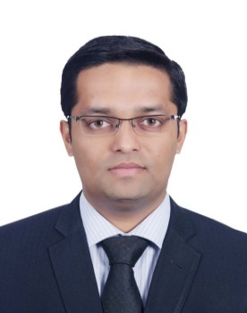
Full Name of Person | Mr Ayan Mukherjee
Company / Organization Name | KPMG India
Designation | Associate Consultant – Infrastructure & Government Services
Address | KPMG INDIA, COMMERCE HOUSE V, 9TH FLOOR, 902 & 903, NEAR VODAFONE HOUSE, CORPORATE ROAD, PRAHLAD NAGAR, AHMEDABAD - 380 051, GUJARAT INDIA
Contact Details | ayanmukherjee1@kpmg.com

Company Profile
KPMG in India was established in September 1993 and today operates from 10 offices around the country. KPMG in India has access to more than 7,000 Indian and expatriate professionals, many of whom are internationally trained. As members of a cohesive business unit they respond to a client service environment by leveraging the resources of a global network of firms, providing detailed knowledge of local laws, regulations, markets and competition.
KPMG in India has offices in Ahmedabad, Bangalore, Chandigarh, Chennai, Delhi, Hyderabad, Kochi, Kolkata, Mumbai, and Pune. We strive to provide rapid, performance-based, industry-focused and technology-enabled services, which reflect a shared knowledge of global and local industries and our experience of the Indian business environment.
Delegate Profile
Mr. Ayan Mukherjee holds an Executive Post Graduate Diploma in e-Governance from Indian Institute of Management, Indore. He has done his graduation in Computer Science & Engineering from Manipal Institute of Technology, Manipal University. Mr. Mukherjee has a combined work experience of more than 4.5 years’ experience, with an experience of around 3.5 years in the Software Industry. He was associated with Tata Consultancy Services Ltd. where he worked extensively as an application developer in the Banking Financial Service domain.

Mr. Mukherjee currently serves as an Associate Consultant in KPMG India’s IGS e-Governance practice. He is currently part of the Vibrant Gujarat 2015 Summit assignment where he is involved in defining appropriate strategies and roadmap for investment promotion activities in Gujarat.

KPMG India is the Knowledge Partner to Government of Gujarat for Vibrant Gujarat 2015 Summit.

